GIẢI BÀI TẬP CHƯƠNG 2
Câu 2:
lw $t1, 20($t0)
add $s0, $s1, $t1

Biểu diễn mã máy tương ứng:
1000 1101 0000 1001 0000 0000 0001 0100 # lw $t1, 20($t0)
0x8D090014

0000 0010 0010 1001 1000 0000 0010 0000 # add $s0, $s1, $t1
0x02298020

Câu 3:
Phân biệt:
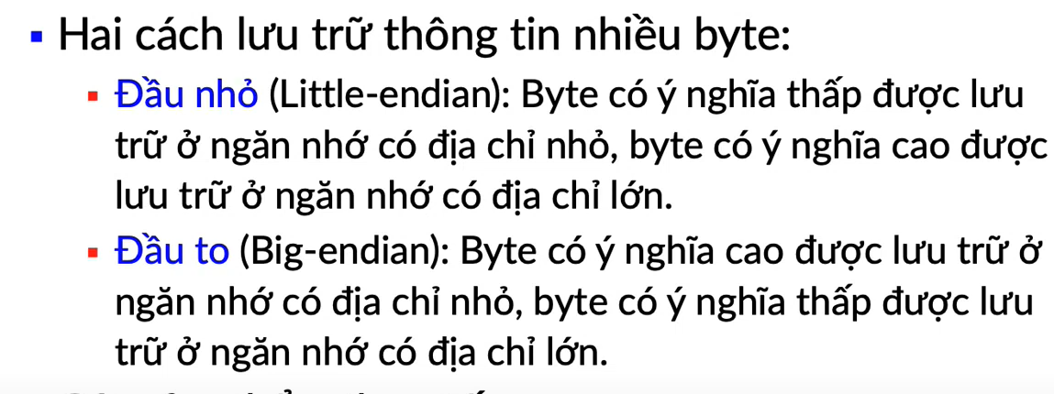
MIPS sử dụng chiến lược big end
Câu 4:
blt $s0, 0, if
add $s1, $zero, $s0
j exit
if:
addi $s1, $zero, 0
exit:
li $v0, 10
syscall
Câu 6:
proc_exa:
add $t1, $s0, $s1
add $t2, $s2, $s3
sub $s6, $t1, $t2
Câu 7:
.data
greeting: .asciiz "Hello World"
.text
main:
li $v0,4
la $a0, greeting
syscall
li $v0, 10
syscall

Câu 8:
.data
name: .space 50
greeting: .ascii "Hello "
.text
li $v0, 8
la $a0, name #Nhap vao ten mot nguoi
li $a1, 50
syscall

li $v0, 4
la $a0, greeting
syscall

li $v0, 4
la $a0, name
syscall

li $v0, 10
syscall

Câu 9:
.data
chuoi1: .asciiz "Nhap chieu dai:"
chuoi2: .asciiz "Nhap chieu rong:"
chuoi3: .asciiz "Chu vi hinh chu nhat la:"
chuoi4: .asciiz "Dien tich hinh chu nhat la:"
chuoi5: .asciiz "\n"
so2: .float 2.0
.text
li $v0, 4
la $a0, chuoi1 #In ra man hinh dong chu "Nhap chieu dai:"
syscall

li $v0, 6
syscall #Nhap vao chieu dai cua hcn
mov.s $f1, $f0

li $v0, 4
la $a0, chuoi2 #In ra man hinh dong chu "Nhap chieu rong:"
syscall

li $v0, 6
syscall #Nhap vao chieu rong cua hcn
mov.s $f2, $f0

li $v0, 4
la $a0, chuoi3 #In ra man hinh dong chu "Chu vi hinh chu nhat la:"
syscall

add.s $f3, $f1, $f2
l.s $f4, so2 # Tinh chu vi hcn
mul.s $f5, $f3, $f4

li $v0, 2
mov.s $f12, $f5 # Chuyen gia tri $f5 vao $f12
syscall

li $v0, 4
la $a0, chuoi5 #In ra man hinh dau xuong dong
syscall

li $v0, 4
la $a0, chuoi4 #In ra man hinh dong chu "Dien tich hinh chu nhat la:"
syscall

mul.s $f6, $f1, $f2 # Tinh dien tich hcn

li $v0, 2
mov.s $f12, $f6 # Chuyen gia tri $f6 vao $f12
syscall

li $v0, 10
syscall

Câu 10:
.data
prompt1: .asciiz "Nhap n: "
prompt2: .asciiz "Nhap k: "
output: .asciiz "Ket qua cua to hop la: "

.text
# Input n
li $v0, 4
la $a0, prompt1 # Print "Nhap n:"
syscall

li $v0, 5 # Syscall code for reading an integer
syscall
add $t0, $v0, $zero # Store n in $t0
add $a0, $t0, $zero # Move n to $a0 for factorial
jal fact # Call factorial function
add $t1, $v0, $zero # Store n! result in $t1

# Input k
li $v0, 4
la $a0, prompt2 # Print "Nhap k:"
syscall

li $v0, 5 # Syscall code for reading an integer
syscall
add $t2, $v0, $zero # Store k in $t2

# Calculate k!
add $a0, $t2, $zero # Move k to $a0 for factorial
jal fact # Call factorial function
add $t3, $v0, $zero # Store k! result in $t3

# Calculate (n - k)!
sub $t4, $t0, $t2 # Calculate n - k
add $a0, $t4, $zero # Move (n - k) to $a0 for factorial
jal fact # Call factorial function
add $t5, $v0, $zero # Store (n - k)! result in $t5

# Calculate k! * (n - k)!
mul $t6, $t3, $t5 # k! * (n - k)!

# Calculate n! / (k! * (n - k)!)
div $t1, $t6 # n! / (k! * (n - k)!)
mflo $t7 # Move result to $t7

# Output the result
li $v0, 4
la $a0, output # Print "Ket qua cua to hop la:"
syscall

li $v0, 1 # Syscall code for printing an integer
add $a0, $t7, $zero # Move result to $a0
syscall

li $v0, 10 # Exit
syscall

# Function to calculate factorial
fact:
# Calculate factorial of $a0 (n)
li $v1, 1 # Initialize $v1 to 1 (factorial result)
factorial_loop:
beq $a0,$zero, factorial_done # If $a0 (n) is zero, exit loop
mul $v1, $v1, $a0 # Multiply $v1 by $a0
subi $a0, $a0, 1 # Decrement $a0
j factorial_loop # Repeat loop
factorial_done:
add $v0, $v1, $zero # Move result to $v0
jr $ra # Return
Câu 11:
.data
int_array: .word 7,10,4,25,20,1,18,3,16,8
len: .word 10
output: .asciiz "Max value:"
.text
main:
li $v0, 4 #Print "Max value:"
la $a0, output
syscall
la $s0,int_array
lw $t1, len
lw $a0, 0($s0)
loop:
addi $t1, $t1, -1 # len=len-1
beq $t1, $zero, exit # len==0 thi tra ve exit
addi $s0, $s0, 4 # &a[i] +4
lw $t0, 0($s0) # $t0 =a[i]
bge $a0,$t0, non_max # if( $a0 >= a[i]) nhay den non_max
addi $a0, $t0, 0 # dieu kien sai thi a[i] == max
non_max:
j loop
exit:
li $v0, 1 # In ra gia tri trong thanh ghi $a0
syscall
li $v0, 10
syscall

Câu 12:
.data
float_array: .float 7,10,4,25,20,1,18,3,16,8
len: .word 10
output: .asciiz "Average:"
.text
main:
li $v0, 4 #Print "Average:"
la $a0, output
syscall
la $s0,float_array
lw $t1, len
addi $sp, $sp, -4 # Lay gia tri len dua vao ngan xep
sw $t1, 0($sp)
loop:
l.s $f0, 0($s0) # $t0 =a[i]
addi $s0, $s0, 4 # &a[i] +4
add.s $f2, $f2, $f0 # $t2 = $t2 + a[i]
addi $t1, $t1, -1 # len=len-1
beq $t1, $zero, exit # len==0 thi tra ve exit
j loop
exit:
lw $t1, 0($sp) # Dua gia tri tu ngan xep vao lai #t1
addi $sp, $sp, 4
li $v0, 2 # In ra gia tri trong thanh ghi $a0
mtc1 $t1, $f1
cvt.s.w $f1, $f1 #Chuyen so nguyen thanh so thuc
div.s $f12, $f2, $f1
syscall
li $v0, 10
syscall
Câu 13:

